Recruitments in Cha’palaa

1. Introduction

This paper offers a first description of one area of everyday interaction among speakers of the indigenous Cha'palaa language of Ecuador, sequences in which one party ‘recruits’ the behavior of another for some practical action. It is based on the analysis of a video corpus of informal conversation, in the context of a comparative project looking at this type of sequences cross-linguistically. After some further introduction to the language and the data considered here, the sections below will present a series of excerpts from the corpus illustrating the particular recruitment practices of speakers of Cha’palaa. In light of the broader comparison, these practices turn out to follow many of the main trends seen cross-linguistically. However, the corpus also stands out in several ways in terms of the specific linguistic formats provided by the grammar like extensive imperative morphology, a general tendency towards being relatively direct and unmitigated in the usage of these resources, and a sensitivity to the specific types of social asymmetries present in Cha'palaa-speaking society.

* 1. The Cha’palaa Language

The Cha’palaa language is spoken by the Chachi people in small communities and households along the rivers of the Ecuadorian Province of Esmeraldas between the Andean foothills and the Pacific coast. It is one of the remaining members of the Barbacoan family, which was once the dominant language family of the region corresponding to northern Ecuador and southern Colombia until it was displaced by Quechua and, later, Spanish, in much of the Andean highlands. The Chachi people avoided the pressure of language shift to Quechua by migrating to the coastal lowlands where they live today (Jijón y Caamaño 1914, DeBoer 1995, Floyd 2010). Estimates of the number of speaker vary between about 6,000 (INEC 2010) and 10,000 (in Ethnologue; Lewis et al 2013).

Until recently, Cha’palaa was a relatively unstudied language, with only a few descriptive sources on the language by missionary linguists produced over the last few decades (Moore 1962, Wiebe 1977, Vitadello 1988); recent work by the author has begun to bring more aspects of the language and the interactive practices of its speakers to light (Floyd 2009, 2010, 2014; Floyd and Bruil 2011, Dingemanse and Floyd 2014). Like many South American languages, Cha’palaa has a basic SOV word order with extensive agglutinating verbal morphology. Some of its grammatical features that are relevant for recruitment practices include its large imperative paradigm, its egophoric system, its complex predicate system, its morphological case markers, and other elements that will be described in the sections that follow

* 1. Data collection and corpus

The video corpus on which this work is based was constructed in accordance with a set of guidelines developed by and for the members of the comparative project being reported on in this volume. The corpora studied in this project feature informal conversation among friends and family, and participants received no special instructions other than to talk or go about their daily activities as they wished. Please see the introduction to this volume (Floyd et al this volume) for a more detailed discussion of the video corpora.

The Cha’palaa corpus was recorded by the author over a period between 2007 and 2013 in household and village settings in Chachi communities of north-western Ecuador. The majority of the recordings come from the Rio Cayapas area, particularly from its tributary the Rio Zapallo, and a few come from other areas. In most cases the camera was placed in a household during regular daily activities and then retrieved after about an hour. All videos included adult participants (adolescents or older), including dyads and larger groups of family members and friends, sometimes changing configuration during filming, with children often coming and going. Participants were involved in cooking, eating, doing other household tasks, making handcrafts such as woven baskets, or simply relaxing and conversing.

The data considered for comparison to other corpora consisted of a coded sample of selections from the recordings. The goal was to identify at least 200 recruitment sequences in each corpus, and because of variations in frequency of cases across recordings and corpora, the precise amount of video sampled varied per language. The nature of the Cha’palaa corpus, made up primarily of recordings in multi-generational households, meant that there were many small children present, which was not the case for several of the other corpora. Because child-directed speech may not be entirely comparable to adult interactions, cases in which one of the involved participants was a small child (not yet adolescent, below about 12 years) were excluded from comparison. Excluding these cases, which were twice as frequent as adult-only cases, lowered the frequency of recruitment sequences and necessitated reviewing a large sample of about 9.5 hours from 16 different recordings to reach a total of 205 cases (out of 653 total, with 448 child-involved cases). Excerpts from this selection of cases are presented below to illustrate the range of linguistic forms and practices that make up the Cha’palaa recruitment system.

1. Basics of recruitment sequences

As defined in the introduction to this volume, a recruitment sequence is a basic cooperative phenomenon in social interaction with the following characteristics:

In a ‘recruitment’ one person elicits some kind of practical behavior from another in a sequence minimally consisting of two moves: Move 1 (M1), in which participant A does or says something to participant B or that B can see or hear, and Move 2 (M2), in which participant B does something practical for participant A. (Floyd et al, this volume).

Further details relevant for this definition, including what happens when M2 rejects the recruitment or when there is no response, will be discussed in section 4. The following subsections give some basic examples of recruitment sequences.

* 1. Minimal recruitment sequence

Extract (1) provides an example of a minimal recruitment sequence in Cha’palaa. In M1, participant A turns to look at participant B, his wife, and uses an interrogative format to invoke a specific target action: ‘Did you sweep? Did you sweep?’ As part of his recruitment, he also adds a reason for doing this action: ‘the child is in all that trash’. Participant B’s reaction is to walk off camera and to return shortly with a broom, sweeping the spot indicated by participant A.

CHSF2011_01_11S2_1531121  
  
1 A mankashyu mankashyu M1  
 ma-n-kash-yu ma-n-kash-yu   
 again-N-sweep-EGO again-N-sweep-EGO   
 did you sweep? did you sweep?  
  
2 na tsamantsa ujtu'paatala  
 na tsamantsa ujtu'-pala-tala  
 small very.much trash-place-among   
 the child is in all that trash  
  
3 B ((leaves)) (15.0) ((returns with broom, sweeps)) M2

The format selected by A in line 1 illustrates how a distinctive feature of Cha’palaa’s grammar, an ‘egophoric marker’ (Floyd, San Roque and Norcliffe, eds, in preparation; also referred to a conjunct/disjunct marker - see Hale 1980, Bickel 2000, Criessels 2008, Curnow 2002, DeLancey 1992, Dickinson 2000, Post 2013) is employed for the interactive function of instigating a behavior on the part of B. This type of knowledge-based morphology used in this context treats the addressee as the locus of knowledge (in statements the marker might associate with the speaker’s perspective in a similar way). More generally, however, question-type formats are used cross-linguistically for recruitments, so while in this sense Cha’palaa may use distinctive morphological resources, it also fits a general pattern. Looking at Move 2, the uptake by B provides evidence that functionally this question was taken as a request for the provision of a service, namely, sweeping up.

* 1. Non-minimal recruitment sequence

While immediately taking steps to accomplish the target action is the simplest response to a recruitment, this does not occur in all instances. Sometimes recruitment sequences sometimes feature more than one recruitment turn; such ‘pursuits’ (Pomerantz 1984; Bolden Mandelbaum, & Wilkinson 2012) of response can generate non-minimal sequences in which speaker A must re-do or clarify the recruitment before it is complied with rejected. In Extract (2) participant A is a woman who is washing her clothes on the shore; she asks her friend participant B for a plastic tub, but before she passes it to A, B requests confirmation of the target object, in line 2. After A provides this confirmation, B accomplishes the target action.

CHSF_2012_08_04S4_1712020  
  
1 A Daira ñaa inu tina ka' eede M1  
 Daira ñu-ya i-nu tina ka-tu ere-de  
 Daira 2SG-FOC 1SG-ACC tub grab-SR pass-IMP  
 Daira you pass me the tub  
  
2 B enstaa? ((pointing at tub)) M2  
 ensta-a  
 this-Q  
 this one?  
  
3 A jee tsadekee M1  
 jee tsa-de-ke-e  
 yes SEM-PL-do-IMP  
 yeah do that   
  
4 B ((throws tub to A)) M2

In these types of non-minimal sequences it is possibly to observe how ‘insert sequences’ or ‘side sequences’' (Schegloff 2007) and other types of intervening material displace the original M1 from the fulfillment of the request. When the request is not fulfilled in the first M1, this can generate further iterations of the M1/M2 structure until the sequence is completed (or abandoned).

* 1. Subtypes of recruitment sequence

Recruitments can be a fairly wide range of phenomena; for this reason the sample was further categorized according to four broad sub-types of sequences, as described in the introduction to this volume (Floyd et al this volume). These categories distinguish cases in which the target action of M1 is best thought of as (1) the provision of a service, (2) the transfer of an object, (3) the alteration of some ongoing trajectory of behavior, or (4) if there was no on-record M1 and participant B stepped in to provide assistance.

|  |  |  |
| --- | --- | --- |
| Recruitment subtype | # in sample | % |
| service provision | 152/205 | 74% |
| object transfer | 42/205 | 20.5% |
| trouble assistance | 7/205 | 3.5% |
| alteration of trajectory | 4/205 | 2% |

Table 1. Relative frequencies of recruitment sequence subtypes (n=205)

Extracts 1 and 2 have already provided examples of the two most frequently occurring categories; in Extract 1 participant A requests the provision of a service, sweeping the floor, and in Extract 2 participant A asks for an object, a plastic tub. Extract 3 shows an example of an alteration of a trajectory of action; A notices that B is sitting in such a way that she appears uncomfortable, and tells her to alter the way she is currently sitting to a more restful position, giving the reason that otherwise her back will hurt.

CHSF2011_06_25S2_3916900  
  
1 A leka leka leka beenbushu kiya M1  
 rest rest rest back hurt   
 rest rest rest, (your) back will hurt  
  
2 B ((reclines)) M2

As illustrated in Table 1, alterations of trajectory were the least frequent of the sequence types in the Cha'palaa sample. Preliminary analysis of the data set involving children, mentioned above in 1.2, show many more attempts to alter and correct behavior in those cases, suggesting that social status may play a role, and that adults may try to avoid such potentially face-threatening interactions among each other, while in similar interactions with children such recruitments may be the norm. Future work with data set of child-involved cases stands to shed more light on these issues.

The last sub-type of case that was included in the sample were sequences in which B steps in to assist A with some problem that, while usually evident from the context, has not been explicitly requested by A. For example, in Extract 4 B and several boys were sitting in front of the kitchen door, scraping and eating coconut shavings. When A begins to approach with a heavy load of bananas, B and the others first gaze at her and then proceed to move the bowls, stools, and other objects out of her way, and to lean to the side to allow her to pass into the kitchen more easily.

CHSF2012_08_05S5_363190  
  
1 A ((walks towards door with load of bananas)) M1  
  
2 B ((moves bowl out of way; leans away)) M2

Image 4a. Participant B and accompanying children collecting coconut shaving in a bowl, while Participant A is approaching with a load of bananas (line 1).

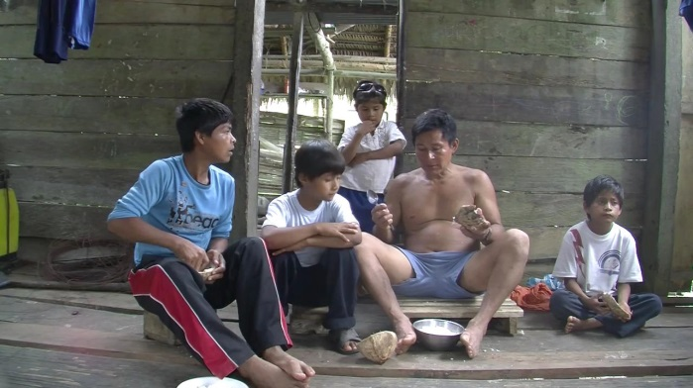

Image 4b. Participant B and children see Participant A approaching and move the bowl and stool out of her way (line 2).

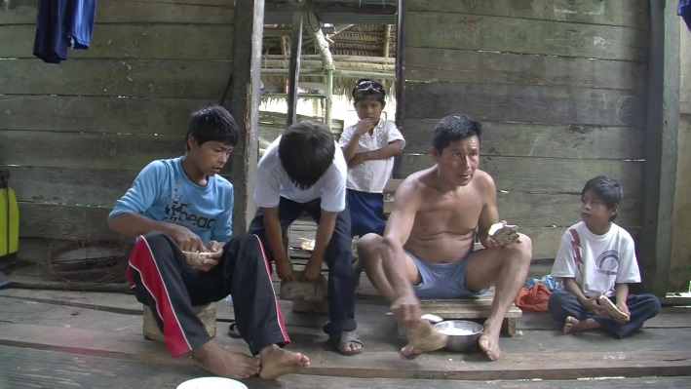

Image 4c. Participant B and children lean out of the way as Participant A passes with her load of bananas (line 2)

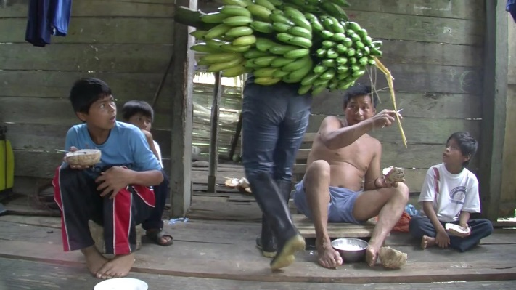

These instances of pro-social behavior differ from the other cases because M1 only exists retrospectively in light of B's reaction in M2, and does not feature any on-record behavior that might be understood as a request for assistance. However, the types of services and objects that B provides in such cases are the same types of local practical actions that were often explicitly asked for in other instances ('Move over so I can pass.' etc.).

1. Formats in Move 1: the recruitment

The formats used by Participant A in M1 could be fully non-verbal, fully verbal, or a composite of verbal and non-verbal elements. This section describes the composition of M1 in both the visual and the spoken channels.

* 1. Fully nonverbal recruitments

Most of the recruitment formats in the Cha'palaa sample included some spoken elements; of the 205 cases sampled, only 9 were fully non-verbal in M1 (excluding cases of 'trouble assistance' which are not on-record recruitments; see Section 2.3). An example of one such case is shown in Extract 5, in which A and B are taking care of an injured chick together. During a moment when no spoken conversation is ongoing, A holds out the chick for B to hold for a moment so A can keep his hands free. B responds to A holding the chick out by reaching up to take it.

CHSF2012_01_20S6_3387180  
  
1 A ((holds out chick)) M1  
  
2 B ((takes chick)) M2

Figure 5a. Participant A holds out his hand and Participant B hands the chick to him.

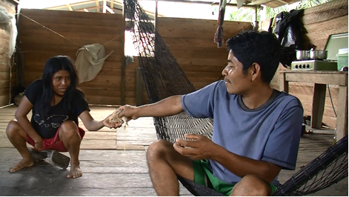

The main formats for nonverbal requests in the sample were holding out objects, as in Extract 5, and holding out the hand to receive objects. These were also two of the major nonverbal formats seen accompanying verbal recruitment formats, the topic of the next section.

* 1. Nonverbal behavior in recruitments

In most recruitment sequences M1 includes no nonverbal behavior that is salient or relevant for the sequence; instead, target actions are usually specified verbally. However, in 55 of 205 Cha'palaa recruitment cases some relevant nonverbal behavior occurred. As mentioned in the previous section, 9 of these were 'stand-alone' nonverbal recruitments, but the other 46 were composites including verbal and nonverbal elements. While some nonverbal behavior was idiosyncratic and did not lend itself to categorization, across all the languages in the comparative project, several well-defined types of practices made up the majority of the nonverbal elements. In Cha'palaa three practices accounted for about 85% of all nonverbal behavior seen in recruitments: Pointing was the most common of these, accounting for 42% of nonverbal elements. Pointing gestures usually indicated an object, location or person that was relevant for the recruitment in some way. The next-most-common practice was holding out an object that is instrumentally involved in the recruitment, as seen in Extract 5, above. The other major practice in the sample was reaching out to receive an object. In addition, there was one instance of iconic gesture (in this case, beckoning for B to approach A) and about 15% were heterogeneous practices that did not fit into any of the cross-linguistic coding categories applied in the comparative project.

|  |  |  |
| --- | --- | --- |
| Practice | # in sample | % of total NVB |
| pointing gesture | 23 | 42% |
| holding out object | 15 | 27% |
| reach to receive object | 8 | 15.5% |
| iconic gesture | 1 | 2% |
| other | 8 | 15.5% |

Table 2. Types of nonverbal behavior in recruitments (n=55).

The following screenshot shows a pointing gesture that accompanied the spoken recruitment turn 'give me the string there' (full sequence shown in Extract 10). Along with his indexical point, he also uses lip pointing, a practice observed commonly among Cha'palaa speakers (Dingemanse and Floyd 2014) and in many other languages (Sherzer 1973, Enfield 2001).

Image 13a. Screenshot from Excerpt 10, line 3; index finger and lip pointing as part of a recruitment M1 format.

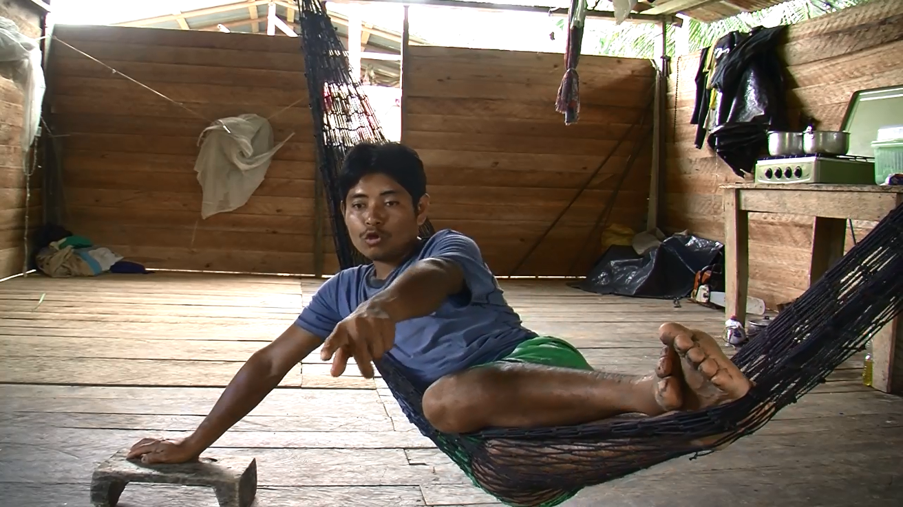

In some cases the nonverbal behavior was relatively complex, as in Extract 6 below, in which A first extends his arm and points at the menthol ointment he is requesting, saying 'give me that also' and, after a brief pause, he provides a reason for the request ('I will smell a little') as he turns his palm upwards to receive the object. One interesting element of the nonverbal behavior is in this case is that A already extended his arm by the first part of M1 in line 1, suggesting that he has high expectations that the request will be fulfilled (based on it being a relative 'low contingency' request; Curl and Drew 2008, Craven and Potter 2010).

CHSF2011_01_11S3_2692960  
  
1 A kuke inuba aantsa (.) jayu ishkeechi M1  
 ku-ke i-nu-ba aansta jayu ish-kera-chi  
 give-do 1SG-ACC-also that little smell-see-INGR  
 give me also that (.) (I) will smell a little   
 ((reaches out pointing; then palm up))  
  
2 B ((hands menthol to A)) M2

Image 6a. A (center left) reaches out while requesting the menthol (in line 1).

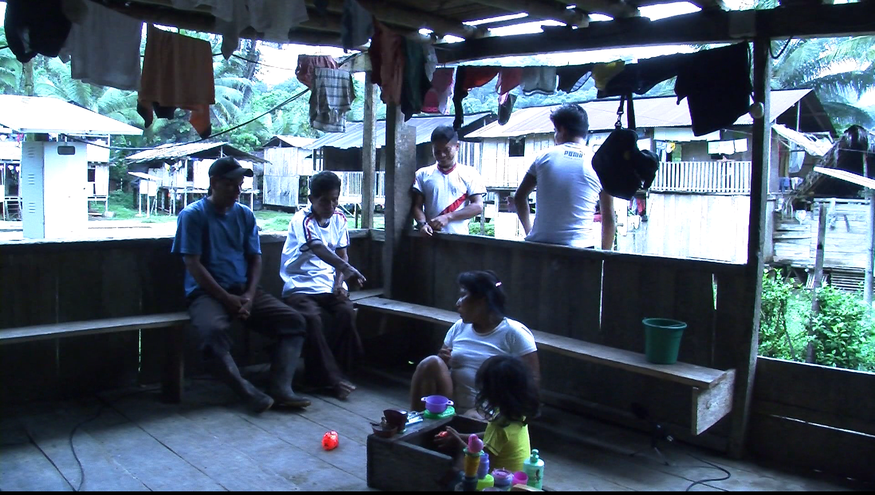

Cross-linguistically, these three practices of pointing, holding out objects, and reaching to receive object made up at least half of the total nonverbal behavior seen in recruitments (and are practices with extremely deep roots, being among the first to appear developmentally, and with analogous practices by some non-human primates; see Tomasello 2008). However, another cross-linguistically consistent fact is that there is an asymmetry between M1 and M2 in recruitment sequences in that while M2 tends to involve nonverbal elements, especially the accomplishment of the target action, M1 is primarily in the verbal channel. In Cha'palaa only 27% of total cases included nonverbal elements in M1, with 73% of M1 formats including verbal elements only. The next sections describe these verbal recruitment formats.

* 1. Verbal elements: construction types and subtypes

The spoken elements of M1 are mainly made up of the morphosyntactic resources of the Cha'palaa language (sometimes also with elements of Spanish). Verbal elements were classified according to cross-linguistic syntactic categories of 'declarative', 'interrogative', 'imperative', cases of 'no predicate', and 'other' for predicates that do not fit well with any of these categories. While not all languages have firm distinctions between clauses that introduce propositions, ask for information or request an action, in most cases Cha'palaa features very clear and unambiguous morphological distinctions on the verb associated with its particular instantiation of the three major sentence types. Languages in the comparative project varied with respect to the relative frequencies of sentence types, but in most cases Cha'palaa can be considered typical, with imperative formats vastly outnumbering all of the others.

|  |  |  |
| --- | --- | --- |
| Sentence type | # in sample | % |
| imperative | 137 | 71% |
| no predicate | 22 | 11% |
| declarative | 20 | 10% |
| interrogative | 13 | 7% |

Table 3. Construction type of recruitments including spoken elements (n=192).

* + 1. No predicate

Reviewing all of the different morphosyntactic types and their functions, we can start with cases in which there was no predicate, which belong to no sentence type in a strict sense. These cases are not all over the map, however, but instead can be classified by a few simple categories: of the 22 cases of 'no predicate', 12 name an object to be transferred, 6 name places that were relevant for the target action, 3 are vocatives selecting the recipient, and one was an interjection. Because the last two categories do not specify the target action, they generally occur as a pursuit of a previous recruitment that was not successful. The other formats can generally function as stand-alone recruitments as well as pursuits. For example, speakers can name destinations as a way to tell addresses to go to those places or take things to or from those places; sometimes other grammatical resources come into play, like the locative case marker with the first person pronoun in Extract 7 that specifies that the addressee should do something to or for participant. Object naming usually functions to request the object in question, sometimes with additional material like in M1 of Extract 7, which also specifies a recipient, but which leaves the target action of ‘giving’ or 'passing' up to interpretation. While unspecified, the requested action is usually obvious from the context, and so this type of recruitment can be considered relatively explicit or on-record.

Also worth noting here is that in M2 B acts towards the fulfillment of the target action, but she does so in a particular way: by delegating to a third party. This was a strategy sometimes observed when the target action was obviously easier for a third party, for example when they were closer to a target object, or of lower social status, both of which were the case for Participant C here.

CHSF2012_08_04S4_1524500  
  
1 A inu jabon M1  
 i-nu jabon  
 1SG-ACC soap   
 to me, soap ((in water; points at soap on shore))  
  
2 B jabon tya'kide apa ñaa M2  
 jabon tyatyu-ki-de apa ñu-ya  
 soap throw-do-IMP 'father' 2SG-FOC  
 throw the soap, son, you   
 ((points at soap))  
  
3 C ((child throws soap to A))

Aside from the 22 cases of M1 without a predicate, all other cases with verbal material in M1 included a predicate of some kind.

* + 1. Imperatives

For no-predicate recruitments, the relevant action should be understandable from the context in order for addressees to respond. However, most of the time speakers gave more information about the target action by producing a predicate (89% of recruitments with spoken M1). Of these, as noted in Figure 3, imperative forms were by far the most frequent type of predicates seen in recruitments. The imperative sentence type in Cha'palaa does not consist of a single construction, but instead features several options that will be described below. Cross-linguistically, imperative verb forms tend to be relatively short, frequently consisting of just a verb root or a root with a minimal marker (Khrakovskij 2001, Aikhenvald 2010). Cha'palaa fits this pattern; its two main imperative constructions are a bare verb root or a suffix, *-de*, seen in line 2 of Extract 7 above. The bare root option is shown by Extract 8. Cha'palaa has a system of complex predicates in which multiple roots combine in single predicates, where one of the roots, usually one of a set of verb classifiers, occurs farthest to the right, and takes the finite morphology (see Floyd 2014; also see Dickinson 2000 for a description of a similar system in a related language). In most cases finite predicates take at least one verbal morpheme, but one of the options for forming imperatives is to use just the verb root. In Extract 8 participant A takes this option, telling B to look at a magazine she is passing to her.

CHSF2011_06_24S3_1304600  
1 A lenke' kerake M1  
 len-ke-tu kera-ke  
 read-do-SR see-do  
 read this ((hands B magazine))  
  
2 B ((takes magazine and reads)) M2

In addition to the two most frequent imperative formats shown above in Extracts 7 (line 2) and 8, Cha’palaa has three further imperative markers, plus plural forms of each. Figure 4 shows each of the formats’ frequencies relative to the other imperative options in the sample. The bare verb form sometimes occurs with a lengthened vowel and a related shift in primary stress to the right, which might be considered a kind of ‘strengthener’ (see section 3.4). The next frequent format is the relatively neutral, unmarked imperative *-de*, which conveys an on-record wish that the addressee do the target action, and a ‘speaker-recipient’ imperative *-ka* that conveys that the speaker is the indirect object and beneficiary. Then there are two hortative formsfor groups the speaker includes him or herself in, one for stronger ‘command’ type recruitment (*-da*)and one for weaker ‘suggestion’ types of recruitments (*-sa*). This final polite option did not occur in the sample, perhaps in connection with the ‘maximally informal’ nature of the recordings (see section 1 and Floyd et al, this volume), which makes the most delicate types of recruitments infrequent.

|  |  |  |  |
| --- | --- | --- | --- |
| Function | Form | Plural | % imperatives |
| bare imperative | V | *(de-)V* | 65% |
| simple imperative | V-de | *(de-)V-dei* | 27% |
| speaker-recipient | V-ka | *(de-)V-kai* | 5% |
| strong hortative | V-da | *(de-)V-dai* | 3% |
| weak hortative | V-sa | *(de-)V-sai* | 0% |

Table 4. The Cha’palaa imperative paradigm, singular and plural forms, and percentages of each format within the total of imperatives in the sample (n=137).

In a few limited contexts, declaratives can also occur as bare verb roots, so the comparable imperative format relies to a small degree on context for disambiguation. Speakers sometimes choose to be more explicit by selecting the imperative suffix *-de*.

CHSF2011_02_14S3_2673050  
  
1 A inu jayu kude aamama shipijcha M1  
 i-nu jayu ku-de aamama shipijcha  
 1SG-ACC a.little give-IMP grandma 'madroña'  
 give me a little madroña grandma ((reaches towards B))  
  
2 B ((turns towards A; begins passing fruit)) M2

It is possible to mark a beneficiary of three-place predicates like ‘give’ with a full noun phrase, as in Extract 9. But there is also a special imperative marker that is only compatible with first person recipients, *-ka*, seen in Extract 10 line 3.

CHSF2012_01_20S6_2952739  
  
1 A vieja  
 old lady  
  
2 B aa  
 huh?  
  
3 A inu chuwa manka' kuka junu jee M1  
 i-nu chuwa ma-n-ka-tu ku-ka junu jee  
 1SG-ACC vine again-N-grab-SR give-IMP1 there yes  
 give me the string there hey ((finger and lip point))  
  
4 B ((brings string)) M2

When the speaker is included as a participant in the target action, one of two different hortatives may be used. The first, *-da*, was the only one of the two attested in the sample, indicating that it is probably used more frequently in general in informal contexts. Extract 11 shows a case of this hortative, when one teenager attempts to recruit another to go fishing.

CHSF2011_02_14S3_3479997  
1 A Gringo  
 Gringo (nickname)  
  
2 B aa  
 huh?  
  
3 A waaku tyuinsha jidaa laaba M1  
 waaku tyui-n-sha ji-daa lala-ba  
 net press-N-LOC go-HORT 1pl-with  
 let's go net fishing, with us  
  
4 B maa waaku tyuindetsun M2  
 mu-ya waaku tyui-n-de-tsu-n  
 who-FOC net press-N-PL-PROG-Q  
 who is going net fishing?

Outside of the sample, looking into the video corpus more broadly, it was possible to find examples of the second hortative, *-sa*. This marker is identical to a dependent clause marker for modal complements, and it is likely that the hortative use developed through processes of ‘insubordination’ (Evans 2007) when the dependent clause developed a conventionalized main clause usage, and became incorporated into the imperative paradigm. It alternates with *-da* as a more ‘mitigating’ option. At present it is so integrated into the imperative system that it takes the plural marker that only combines with imperative forms, *-i*. Extract 12 shows an examples of the plural form of *-sa*.

CHSF2012_01_07S1_137560  
  
1 A jisai lalaa M1  
 ji-sai lala-ya  
 go-HORT2.PL 1PL-FOC  
 let's go  
  
2 B ((leaves house with A)) M2

The imperative system is flexible, plural marking is available but optional, and the motivations of speakers for choosing one of the three second person imperatives or one of the two hortatives are difficult to fully determine. This grammatical flexibility provides diverse options for different interactional contingencies.

* + 1. Interrogatives

One of the most important aspects of imperative formats for recruitments is that these are the most overt, on-record morpho-syntactic option for requesting an action on the part of an interlocutor (along with no predicate formats, which are usually unambiguous requests for action in context). The lexical semantics of imperative constructions definitionally conveys the speaker's wishes that the addressee do something. The other main sentence types, interrogatives and declaratives provide ways for instigating a responsive action without going fully on-record, and have been discussed with respect to 'indirectness' in speech acts (Searle 1969, Levinson 1983). Interrogatives often inquire about pre-conditions for the request, creating a 'pre-sequence' (Schegloff 1980, 2007) but conventional use of interrogative formats for pre-requesting can result in the 'collapse' of the pre-sequence to the point that interrogatives can act as stand-alone request formats. This is the case with the format seen in line 1 of Extract 9, which inquires about the availability of an object ('Is your saw not there?'), but which ends up being taken as a request for the object.

CHSF2012_01_21S3_2615530  
  
1 A ñuchi serruchu tsutyuu M1  
 ñu-chi serruchu tsu-tyu-u   
 2SG-POSS saw lie-NEG-Q  
 is your saw not there? ((off camera/outside of house))  
  
2 B aa M2  
 huh?  
  
3 A serruchu tsutyuu   
 serruchu tsu-tyu-u   
 saw lie-NEG-Q  
 is (your) saw not there?  
  
4 B enku (.) tanami ibain (.)  
 e-n-ku ta-na-mi i-bain   
 here-N-LOC have-be.in.POS-DECL 1SG-  
 also here, I have it,   
  
5 jayaa finberaya  
 jayu-ya fi-n-bera-ya  
 little.bit-FOC eat-still-FOC  
 it ‘eats’ a little (it saws decently)  
  
6 seruchu tii  
 serruchu ti-i  
 saw say-Q  
 did (he) say ‘saw’? ((to C))  
  
6 C mm  
 yeah  
  
7 B ((goes to get saw, returns))  
  
8 Ebe jee  
 Ebe hey  
 here Ebe ((holds out saw))

Going through the interaction above line by line helps to illustrate how a question about the presence of an object is treated by the participants as a request for the object. In line 1 A inquires about the saw, using the verb 'lie', which is the appropriate positional verb for elongated objects on flat surfaces. Possibly because A is standing outside the house and did not have B's full attention, B displays some trouble hearing line 1 and initiates repair in line 2, occasioning a full repetition in line 3 (typical for an 'open' repair initiator, Drew 1997; see Floyd submitted for a description of the Cha'palaa repair system; also Enfield et al 2012, Dingemanse et al 2014 on repair interjections cross-linguistically; Cha'palaa stands out because of its falling intonation of the interjection *aa*). In line 4, B answers the question, confirming that the saw does in fact exist. But this is not all he does; in line 5 he also gives some information about the status of the object with respect to its function ('It saws decently'), giving evidence that he understands that lines 1 and 3 are geared towards getting the saw. Interestingly, B has chosen to respond to A even though he appears to not be fully certain of the target action, as in line 5 he requests further confirmation from his wife C. After this, B proceeds to fulfill the request in 8, but at no point has A overtly asked to be given the saw.

Interrogative recruitment formats like that seen above in Excerpt 13 are more frequent in cases of requests for transfers of objects like that seen above; compare 7% of interrogative recruitments in the total sample with 20% for object transfers (9/44). Additionally, if the object is not visible interrogatives are used in 47% of cases (8/17); this is to be expected, because these are canonical contexts in which a participant might check the pre-conditions for a request before making it, thus avoiding rejection on the grounds of a faulty presupposition that the object was available. In other situations, other interrogative formats can be used. In cases of requests for the provision of services, for example, a speaker might ask a question about a target action to convey that they would like an addressee to do this action. An example of this was seen Excerpt 1 with the question 'Did/do you sweep?' The common feature of all the different types of interrogative recruitments is that in different ways they use what is on the surface a request for information as a way to request an activity.

* + 1. Declaratives

Declaratives are another format for less direct or less on-record requests. These work by introducing a proposition about some state of affairs, but with an implicit understanding that some action should be taken by an addressee. This format allows speakers to avoid explicitly selecting an addressee for the recruitment. In some cases the addressee may be obvious from the context - if A is gazing directly at B, for instance, or if the interaction is dyadic - while in other cases participants might self-select and construe themselves as the addressee. One cross-linguistically common format for declarative recruitments is deontic statements about how things should be, or what things need to be done. Extract 10 provides one such example of a deontic construction in Cha'palaa, which is formed with the combination of an infinitive verb and a copula (a very common deontic construction type in South America; Mueller 2013). In this case a husband A and wife B were working together to nail in some boards to repair a wall, and when A makes a statement about the task should be done, B responds by altering the way in which she is performing the task.

Extract 14. CHSF201  
  
1 A tu- tu'pushujuntsaa kanu juaa M1  
 tu- tu'pu-shujunsta-ya ka-nu ju-ya  
 nail nail-REL.CL grab-INF be-FOC  
 (one) must grab the part that was nailed   
  
2 B ((grabs and moves board)) M2

Research on some European languages has shown similar usages of deontic contructions (Zinken and Ogiermann 2011; Rossi 2012, forthcoming; Stevanovic 2013), suggesting that this particular strategy may be cross-linguistically recurrent. Apart from the specific deontic constructions seen above, a further wide range of declarative construction types can function as recruitments in the right contexts. For example, Extract 15 is a case of a pursuit of a recruitment that was not fulfilled after the first attempt, which was an imperative: 'Look for lice on me'. While a bit taboo in Western cultures, picking parasites of each other is an important social interactive practice among peoples from different parts of the world, including the Chachis of Ecuador, for whom it is considered an affectionate form of behavior most common among family members. In this case, however, when A tells her husband B to groom her in this way, he displays no uptake, and continues a parallel line of conversation, leading to a second attempt by B in line 3, this time in a declarative format.

CHSF2012_08_04S4_1524500  
  
1 A inu mu keraa M1  
 i-nu mu kera-a  
 1SG-ACC lice look-IMP  
 look for lice on me ((sits with back towards B))  
  
2 B ((no uptake; 88.0 unrelated conversation))  
  
3 A ñaa inu mu keetyunkayu mm mm M1  
 ñu-ya i-nu kera-tyu-n-kayu mm mm  
 2-FOC 1SG-ACC see-NEG-N-EV mm mm  
 you aren't looking for lice on me, hey   
 ((scratches head))  
  
4 B ((no uptake; continues unrelated conversation))

Participant A had been sitting with her back to her husband, giving him access to her hair, for over a minute when she makes a second attempt at the recruitment (line 3). This time she uses a declarative format, using a negation construction to call attention to a state of affairs that is not currently the case (‘You aren’t looking for lice’). In light of the first, more overt recruitment in line 1, this statement can be taken as a request that B do something so that it is the case.

* + 1. Other construction types

In addition to the verbal morphology, there are specialized verbal constructions that can be resources for recruitments. One good example of this is a benefactive construction using the verb ‘give’ as an auxiliary to indicate beneficiaries, a construction which appears in several other unrelated local languages and may be a product of areal convergence (see Bruil 2008 on Ecuadorian Spanish and Quechua).

CHSF2011_02_14S3_1828314  
  
1 A panda tune' kude junka tsai kalarade M1  
 panda tune-tu ku-de junka tsai kalara-de  
 food cook-SR give-IMP there SEM take.photo-IMP  
 'give them' cooking plantain (i.e. 'cook it for them'),  
 appear (in the video) doing like that  
  
2 jee junka kera' uyudenaa tinkai  
 jee junka kera-tu uyu-de-na-ya ti-n-kayu  
 hey there see-SR stand-PL-POS-FOC say-N-EV  
 yeah, they say they are just standing there watching  
  
3 B panda tsunami nain M2   
 panda tsu-na-mi na-i-n  
 food lie-POS-DECL how-become-Q  
 how is there plantain?

In line 1 a verb marked for same subject combines with the verb ‘give’ to convey that it is not for A but for her family members that she is asking that B prepare food. This ‘benefactive give’ construction is not a sentence type, and can occur with any of the major sentence types, nor is it dedicated to recruitments, but when it occurs in the imperative or as part of a recruitment format otherwise, it has the effect of introducing beneficiaries through a conventionalized use of a ditransitive predicate to modify the argument structure. In addition to the main clause, in Extract 16 A also adds some additional elements, including an explanation for the request in line 2; the next section covers the additional elements other than the core elements of the recruitment clause.

* 1. Additional verbal elements

In addition to the predicate and its core arguments, there are other aspects of turn design that are relevant for recruitment formats. This section reviews several of these non-core elements.

* + 1. Strengtheners and mitigators

Some non-core elements can be considered ‘strengtheners’ or ‘mitigators’ with respect to how they upgrade or downgrade the pressure for a response. One common strengthener in Cha’palaa is the word *jee*, which shares several functions: it is the main positive polarity token (‘yes’), a vocative often used to secure attention (‘hey’), and a strengthening element in recruitments. Usually these different functions can be easily distinguished from their context of use, although there appears to be some connection between the vocative use of *jee* alone and its use as part of recruitments, like in Extract 17 in which the recruitment has to do with establishing joint attention.

CHSF2011_06_25S2_4528930  
  
1 A kerake jee M1  
 kera-ke jee  
 see-do yes  
 hey look ((points at toe))  
  
2 B chachi jumiba main kuchinu neepa jelekenu M2   
 chachi ju-mi-ba main kuchinu neepa jele-ke-nu  
 person be-DECL-CNTR one dirty foot fear-do-INF  
 although (you) are human (that is) a scarily dirty foot  
 ((looks at B's foot))

Here A asked B to direct her gaze towards A’s toe in order to jointly evaluate its status, and fulfillment is constituting by re-directing attention and producing an assessment of what is perceived. Above, in Extract 9 line 8, *jee* is used as part of the fulfillment of an object transfer (‘here take this’). Strengthening in these types of sequences can mean emphasizing the need for joint visual attention.

Another quite different format for strengthening consists of modulating the volume of the spoken elements of the recruitment. Extract 18 provides a good example of this strategy in the context of a pursuit sequence. The initial recruitment in line 1 concerns A telling his wife B to hold onto a string so he can tie it. In line 3 he produces a second recruitment giving more information about the position he wanted her to hold ('on the tip'), implying that her first attempt at fulfillment had not been totally acceptable. Then in line 5 he repeats the recruitment from line 3, consisting of a noun *kapa*, meaning the 'side' or 'tip' of an object, and a locative suffix *-nu*, with the main modification that it is produced at higher volume.

CHSF2012_01_20S6_2509823  
  
1 A tadi M1  
 ta-di  
 have-come.into.POS   
 hold (this)  
  
2 B ((begins to hold string)) M2  
  
3 A mm kapanu M1  
 mm kapa-nu  
 yeah side/tip-LOC  
 yeah, on the tip  
  
4 B ((begins to hold more firmly)) M2  
  
5 A KAPANU M1  
 kapa-nu  
 side/tip-LOC  
 on the tip!  
  
6 B ((holds firmly so that A can cut string)) M2  
  
7 A enu main kake  
 e-nu main ka-ke  
 here-LOC one grab-do  
 grab one here

It is easy to see the different in the two pronunciations of *kapanu* from the WAV form of the audio recording. By contrasting these forms that have the same basic form but differing levels of intensity it is possible to see how participant A used the volume level as an upgrade in his pursuit of his recruitment.

Image 18a. WAV form of lines 3-5 of Extract 18, comparing the different volume levels of two successive productions of the same word.

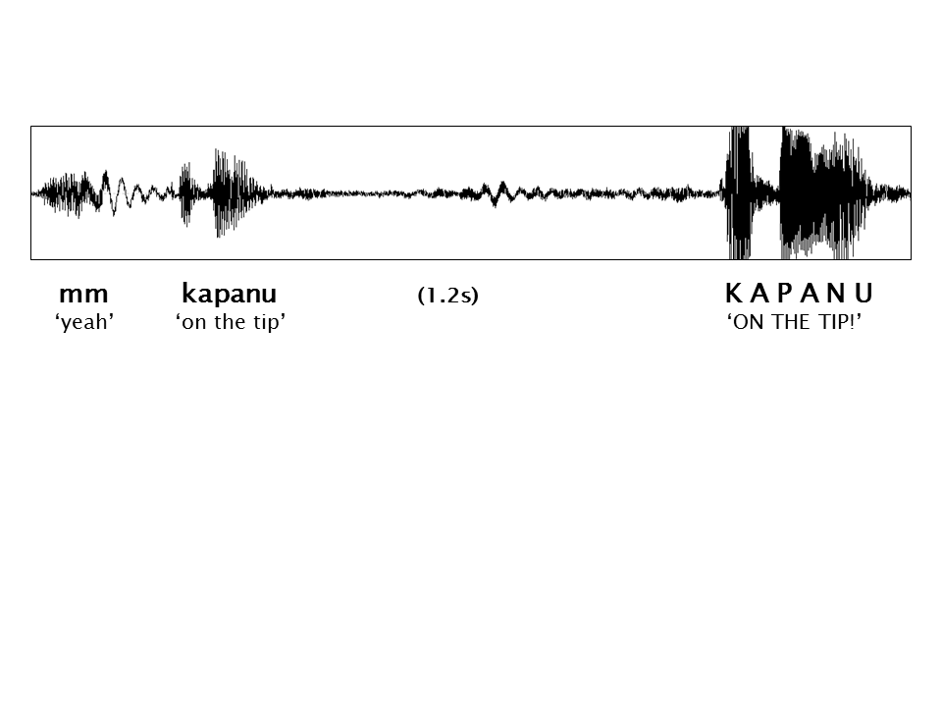

It is interesting to note that the two strengthening strategies discussed here, the particle *jee* and increased volume, both have connections to strategies for securing the attention of an addressee, either through using a vocative like 'hey!' or by making the words more perceptually salient by amplifying them. If other languages show a similar overlap between formats for dealing with attentional issues and formats for strengthening recruitments, it could turn out that this is a frequent cross-linguistic connection based on fairly straightforward semantic links between securing attention for a recruitment and pursuing its fulfillment.

In addition to 'strengthening' recruitments, Cha'palaa speakers also used different formats for 'mitigating' them, or downplaying the contingency of the recruitment. One of these is a minimizing strategy that uses the word jayu, or 'a little bit', in order to frame a recruitment as something small, insignificant, or easily accomplishes. Work on politeness strategies has noted that words or morphemes about smallness are a cross-linguistically common strategy for managing face-threating acts like recruitments (Brown and Levinson 1987). In Extract 19 A tells his wife to 'make rice', but then adds the word *jayu*. The word order is relevant because Cha'palaa is in most cases verb-final and modifiers like *jayu* generally precede their nouns, suggesting that here it was added on as a late-stage calibration of the contingency of the recruitment.

CHSF2011_02_15S4_6949122  
1 A arosya kee jayu M1  
 aros-ya ke-e jayu  
 rice-FOC do-IMP a.little  
 make a little rice  
  
2 B ((gets out of hammock)) M2

* + 1. Explanations

Another type of strategy for mitigation of recruitments is the provision of explanations (including 'accounts' and similar), that provide background information that presents the target action as more necessary, justified or reasonable. For example, in Extract 20 speaker A tells speaker B to 'clean the baby's face', which is very specific about the target action and its beneficiary, and could be a complete recruitment on its own. However, A also adds the phrase 'it is dirty', which provides motivation for the target action.

CHSF2011_02_15S4_499970  
  
1 A nanu kajuru mankijtikee kuchinuu M1  
 na-nu kajuru ma-n-kijti-ke-e kuchinu-ju  
 small-ACC face again-N-clean-do-IMP dirty-be  
 clean the baby's face, it's dirty  
  
2 B ((gets up, takes baby and starts washing face)) M2

Additional elements beyond the core recruitment clause like those reviewed in this section were not extremely common in the Cha'palaa sample. Explanations were present in about 16% of cases in the sample, while just 3% included other types of mitigators. Strengtheners were also infrequent, occurring in only 8% of cases. A discussed above, a further 4% had no verbal material at all, but the remaining 69% of the sample consisted of spoken core clausal elements with no relevant additional spoken material.

1. Formats in Move 2: the response

Like in M1, the recruitment, M2, the response, can also be fully nonverbal, fully verbal, or a composite. But in this sequential position, speech and nonverbal behavior are subject to different conditions than in the initial position of most recruitment sequences. Since the cases in the sample all involved practical actions that could be accomplished or begun during the interaction, most cases included some kind of nonverbal behavior in the response. Of the 163 Cha'palaa cases in which speaker B was clearly visible in the video, 65% had some kind of visual element in the response, while only 34% had a spoken element (with some overlap; 20% combined verbal and nonverbal). 23% of cases in which B was visible had no response at all, showing how ignoring was also an option speakers sometimes chose, but this rate decreases with sequence-final recruitments (125 cases of stand-alone or last in a sequence) to 12%, probably because recruitments that are initially not perceived or ignored may be pursued until they are responded to. This section reviews the trends seen in these responses to recruitments in the Cha'palaa sample.

* 1. Fully non-verbal responses

Half of the total responses to the set of cases in which B is visible in the video consisted of non-verbal elements only, usually the accomplishment of the target action. Because some target actions could be accomplished quickly (e.g. 'to me, the soap') while for other types of actions B can only respond by beginning some activity that A can understand as projecting the completion of the target action (e.g. 'cook a little rice'). Extract 21 gives an example of the former, a case of a request for the alteration of a trajectory of ongoing activity that was fulfilled immediately after M1. B had been holding a baby but was not devoting full attention and the baby was beginning to slip out of his grasp. A, noticing this, prompts B to hold the baby more firmly. B's change in behavior is immediate, includes no verbal elements, and is treated as a satisfactory fulfillment, in that it is no longer pursued by A beyond line 2.

Extract 21. CHSF2011_01_11S3_4728040  
  
1 A kake kake kake M1  
 ka-ke ka-ke ka-ke  
 grab-do grab-do grab-do  
 grab (him) grab (him) grab (him)  
  
2 B ((hold baby more carefully; baby stops slipping)) M2

Also notable is the repetition of the recruitment predicate in line 1. Stivers (2004) notes that this type of repetition is associated with urgency; in the Cha'palaa corpus such examples occur several times in cases of requests for the alteration of a trajectory of behavior. As these recruitments deal with already-ongoing activities, in many cases they are more urgent than requests for services or objects, since the potential negative effects of not fulfilling the request may be mounting while the recruitment move is being produced (see also Extract 3, above, for a similar example of repetition in a case of urgency).

* 1. Verbal elements of responses

Turning to the cases in which some spoken element was part of the response, some of these were rejections, especially when only a verbal element was present, as these cases included no practical activity fulfilling the request. However, verbal elements could accomplish other things as well in the sequential position of M2. For example, in Extract 9 above, participant B initiated repair with an interjection after the initial M1 (see Floyd, in preparation, for a sketch of the Cha'plaa other-initiated repair system). Another thing that verbal elements of responses can accomplish is to manage the temporal contingencies of the sequence. For example, in Extract 22, participant A asks participant B to take a basket, which A is holding out, but B is unable to immediately comply, so she makes it known that she intends to do the target action soon with the utterance 'wait a little'.

Extract 22. CHSF2011_06_25S2_3468149  
  
1 A aanku ka' tsuude M1  
 aanku ka-tu tsure-de  
 there grab-SR lie-CAUS-IMP  
 there get it and set it down ((holding out basket))  
  
2 B kai keedi ((continues previous activities)) M2   
 kayi kera-di  
 little see-come.into.POS  
 wait a little  
  
3 (1.5)  
  
4 ((takes and moved basket)) M2cont.

In the first image A is holding out the basket for B to take, but B's hands are busy (she appears to be rubbing saliva on a dry area of her arm). Often if there is no immediate nonverbal response, speakers pursue with further recruitment turns. However, because B conveys to A she will address the target action shorty, A simply waits with the basket outstretched for a couple of seconds; in the second image, B takes the basket and sets it down as A requested.

Image 22a. Participant A holds out basket for Participant B and tells her to ‘get it and set it down’ (line 1)

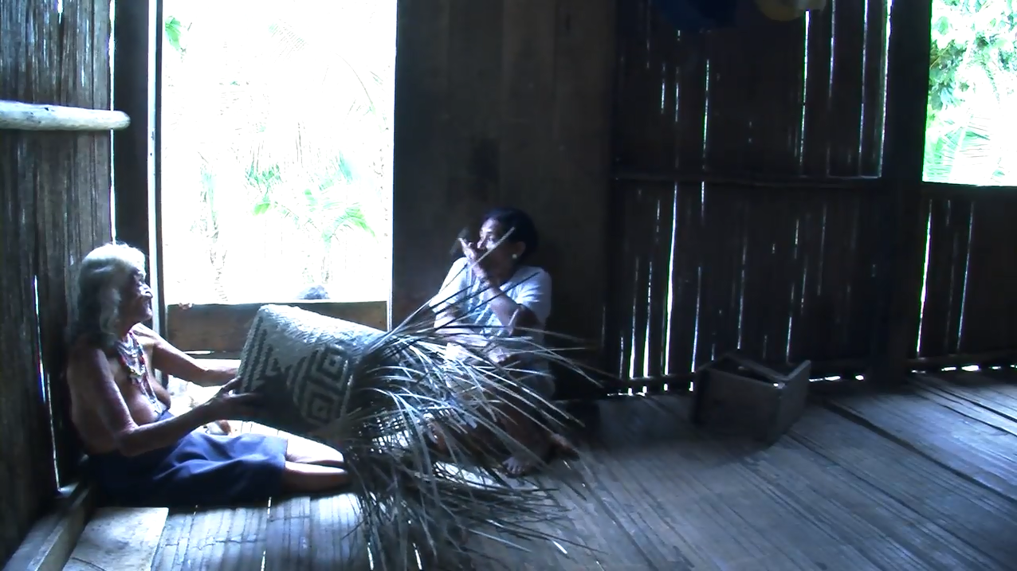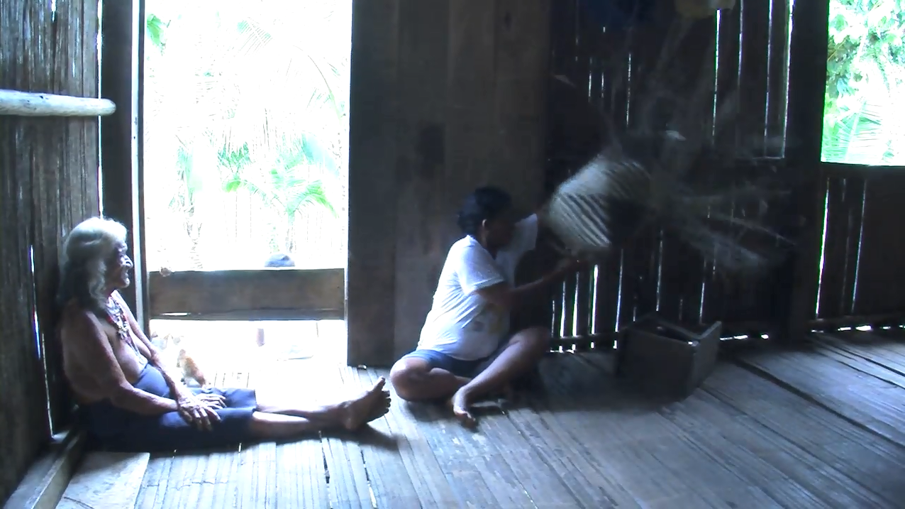

Image 22b. Participant B takes the basket and sets it down (line 4), after having delayed a moment, saying ‘wait a little’ (line 2).

* 1. Types of rejections

As pointed out in the introduction, rejection was rare for all languages in the comparative project, and Cha'palaa is no exception. Only 4% of total cases featured rejection as the response, compared to 46% which included fulfillment. The fulfilment rate is even higher (53%) when considering only sequence-final cases, reflecting how unsuccessful first attempts can be pursued for eventual fulfillment. One type of response to such first attempts might be repair initiation, which accounted for 8% of total responses (predictably, this rate was much lower in sequence-final cases).

|  |  |  |  |  |
| --- | --- | --- | --- | --- |
| response type | total cases (n=205) | % | sequence-final cases (n=125) | % |
| fulfillment | 95 | 46% | 67 | 53% |
| no detectable response | 54 | 26% | 31 | 25% |
| other | 33 | 16% | 20 | 16% |
| repair | 16 | 8% | 1 | 1% |
| rejection | 7 | 4% | 6 | 5% |

Table 5. Fulfillment, rejection, and other response types in the Cha'palaa sample (n=205).

Other options available to participant B in M2 include no response at all, or some other type of behavior that cannot be easily classified as either fulfillment or rejection, such as beginning or continuing some other sequence. These other types of responses were generally more frequent than overt rejection, and so it seems that Cha'palaa speakers tend to opt for less explicit forms of avoiding uptake of recruitments besides overt rejection.

A few of the cases of rejection in the sample are nonverbal only (14% of rejections). In Extract 23, B is holding a slingshot that A reaches for. Instead of releasing the slingshot to A, B pulls his arm back so that A cannot reach it.

CHSF2011_01_11S3_2717590  
  
1 A ((reaches for slingshot)) M1  
  
2 B ((pulls hand away)) M2

Image 23a. Participant A (in center in shirt with stripe) reaches for the slingshot (line 1) as Participant B (right) pulls it back out of reach (line 2)

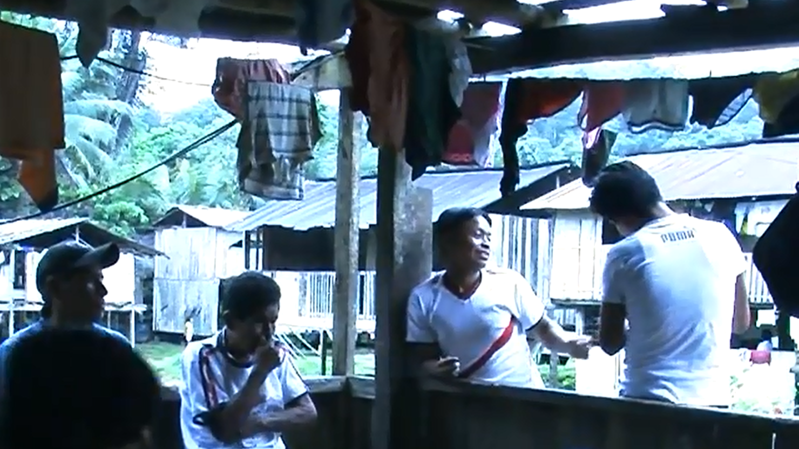

When there is spoken material in a rejection, most often it can be classified as an 'account' or explanation for why B is unwilling or unable to comply (86% of rejections). Extract 24 is a good example rejection through an explanation. A, B and other friends are washing clothes together, but B is getting ready to leave while A still has more to wash. A asks B to accompany here by doing some more washing. However, B has no more clothes to wash, so she offers this state of affairs as an explanation for why she cannot fulfill the request.

CHSF_2012_08_04S4_1193345  
  
1 A tsaaren manpipunaa manbije M1  
 tsaa-ren man-pi-pu-nu-ya man-bije  
 SEM-PRECIS again-water-put-INF-FOC again-time  
 so (you) will wash one more time  
  
2 B naaketaa manpipunu M2   
 naa-ke-tu-ya man-pi-pu-nu nejtu-ya de-i-ñu  
 how-do-SR-FOC again-water-put-INF   
 how can (I) wash?  
  
3 nejtaa yumaa deiñu M2cont.  
 netju-ya yumaa de-i-ñu  
 because-FOC now CMPL-become-DR  
 since it is now finished

Image 24a. Participant A (center, foreground) asks Participant B (right) if she will continue to accompany her washing clothes (line 1). Participant B rejects (line 2) and offers an explanation (line 3).

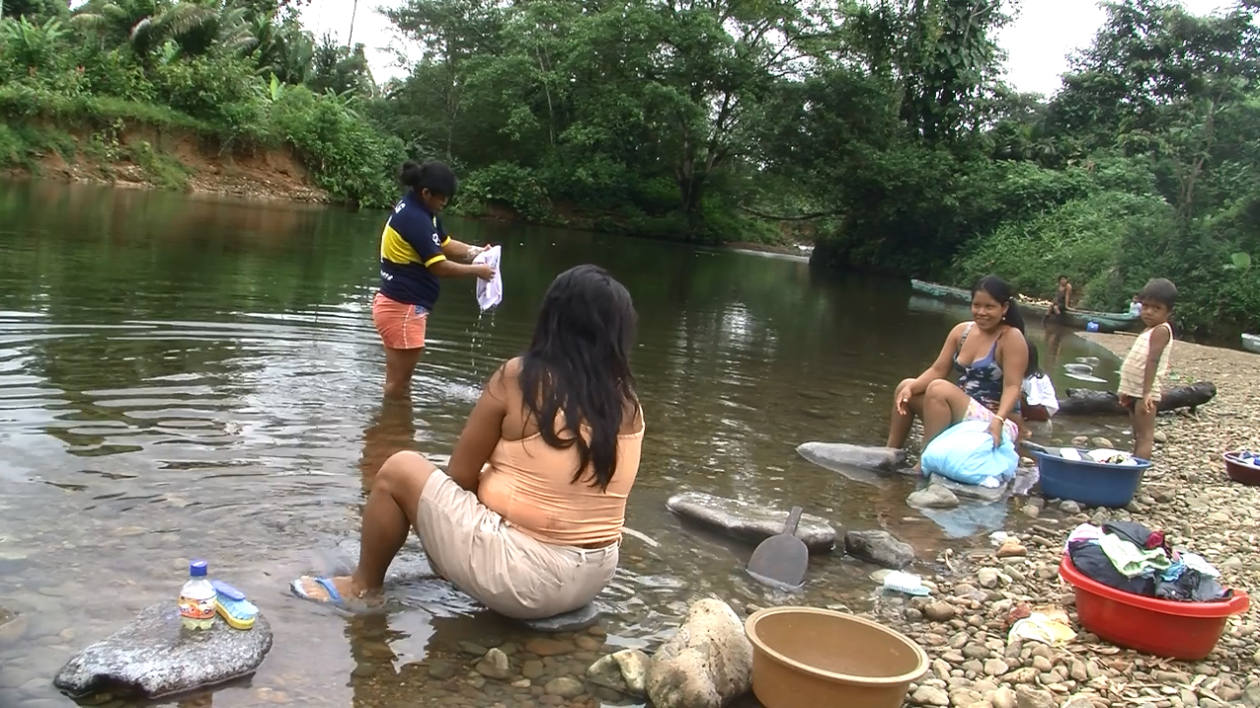

The format that B chooses includes a main clause that accomplishes the rejection calling into question her ability to perform the target action ('how can I wash?'), as well as a clause providing an explanation, including the word *nejtu* which can be translated as 'because' or 'since' ('since it is now finished'). Requesters generally accepted such explanations amicably and did not insist, and such rejections do not seem particularly conflictive or strongly face-threatening. Here Participant B is smiling as she rejects the request (on shore on the right). It is possible that in a sample including higher-contingency recruitments the interactions would be more delicate and include more management of potential disaffiliation, but these types of rejections to mundane requests generally go off smoothly in the Cha’palaa sample.

One final point about rejection formats is that there are relevant connections between the formats seen in the recruitment M1 and the formats seen in the response in M2. Particular first pair parts make relevant the provision of 'type-conforming' responses (Raymond 2003). For example, the recruitment in Extract 25 is in the format of an interrogative clause inquiring about the existence of a target object, which is a common format for requesting objects that are not visible as discussed in section 3.3.3 The response in line 2 both answers the question with the appropriate format and at the same time accomplishes rejection by appealing to an explanation citing the lack of the target object.

Extract 25. CHSF2011_01_11S2_249991  
  
1 A lemu tsutyuu, lemu deii M1  
 lemu tsu-tyu-u lemu de-i-i  
 lime lie-NEG-Q lime CMPL-become-Q  
 there no limes, are the limes up? ((turns towards B))  
  
2 B lemu jutyu kaa ruku M2   
 lemu ju-tyu kaa-ruku  
 lime be-NEG DIM-man  
 there are no limes little husband   
 ((reaching into basket))

Since B has done due diligence here by checking the basket to see if there are any limes, she does not end up being held accountable for non-compliance with the recruitment. The fact that in most sequences with rejections speakers are able to maintain their affiliative stance suggests that they may be avoiding the most fraught exchanges altogether when possible. In general, the high fulfilment rate and low rejection rate indicate an orientation to affiliation in such sequences in Cha'palaa interaction in two senses: first, people tend to fulfil recruitments, and second, people may be avoiding recruitments altogether in cases that are likely to be rejected (see Section 5 on social asymmetry).

* 1. Acknowledgements

After M1 and M2, recruitment sequences may optionally include a move in third position by A that acknowledges the fulfillment of the recruitment. While in principle speakers of any language can make a positive assessment in this position, in some languages, there are conventionalized resources that function as this type of sequence-closing third, like the English 'thank you'. Cha'palaa speakers are familiar with such linguistic resources through contact with Spanish, that has the format 'gracias', but when asked if there is a Cha'palaa equivalent, they end up puzzled and unable to think of anything. This illustrates how practices like saying 'thank you' can be highly variable across cultures, and perhaps in some cultures largely irrelevant (CITE lit on thanking).

In Cha’palaa recruitment sequences, speakers tend to either close the sequence or continue some other conversational trajectory after M2, where in other languages third-position acknowledgment practices are sometimes observed. The video corpus was collected in highly informal contexts, so acknowledgments might be expected to be infrequent for mundane requests among speakers who are highly familiar to each other. However, even in these contexts all speakers of all of the other languages showed some evidence of orientation to this kind of 'face work' (Goffman 1955, Brown and Levinson 1987), while speakers of Cha'palaa did not. Along with its preference for direct imperative formats over less direct interrogative and declarative forms, this suggests that some of the typical practices associated with politeness in English and many other languages are quite different among speakers of Cha’palaa.

1. Social asymmetries

Differences in social status among interactants is highly significant for how recruitment sequences play out, but these are more difficult to characterize analytically than, for example, the morphosyntactic formats seen in those sequences. The most reliable method for assessing how social asymmetry may be relevant for a given society in the mundane, everyday contexts considered in this study is long-term ethnographic observation and participation in the community. Based on my experience in Chachi communities over a period of about 8 years, including one full year spending two weeks per month in the field (2008-9), I can say that the most relevant types of social asymmetries that I observed are based on a combination of age, gender, and kinship relations. Grounded on this information, each dyad was classified as symmetrical or asymmetrical.

The Chachi people have a system of traditional law that governs questions of morality, based around strong gender roles and normative family structure, and punishing transgressions like adultery or marriage outside the ethnicity (Barrett 1925, Altschuler 1967, Floyd 2010). The male and female roles in the family are well-defined, and men and women are responsible for different tasks. Men usually participate in hunting and fishing, some agriculture, logging and canoe-making, while women are in charge of household work like cooking, cleaning and childcare, in addition to some agricultural tasks and handcrafts like basket weaving. Most of the mundane activities that made up the target actions in the sample of recruitment cases from the Cha'palaa corpus were the types of household activities that many Chachis consider to be women's responsibilities. For that reason, in most cases when men directed recruitments at women, typically men telling their wives to do things, I classified such cases as high status recruitments directed at lower status individuals (A>B). Additionally, children are accountable for a number of household responsibilities such as carrying buckets of water from the river and assisting adults in their tasks. While cases involving young children were excluded from the sample as described in Section 1.1, adolescents usually continue to be accountable for such tasks until marriage, so cases of adult family members like parents, grandparents or aunts and uncles directing recruitments at adolescents and young adults were also classified as A>B. Cases with the inverse situation, when adolescents told their elders to do things or wives told their husbands to do things, were classified as low status individuals directing recruitments at higher-status individuals (A<B). All other cases among adults with no relevant family relationships were classified as symmetrical (A=B).

|  |  |  |
| --- | --- | --- |
| (a)symmetry | # cases (n=201) | % |
| A>B | 77 | 38% |
| A<B | 18 | 9% |
| A=B | 106 | 53% |

Table 6. Relative frequencies of dyads by type of social (a)symmetry.

Section 4.3 discussed the possibility that the high rate of fulfillment versus rejection in the Cha'palaa recruitments sample can be in part accounted for because individuals who may not be socially entitled to make certain requests may simply avoid them as a way to avoid potential rejection. In their model of politeness, Brown and Levinson (1987:69-74) proposed this option as preferable in cases in which the contingencies are too extreme to attempt the face-threatening act. While more than half of the recruitments in the sample were between individuals classified as socially symmetrical, there were also over four times more A>B recruitments than A<B recruitments. Based on this, it appears that Cha'palaa speakers are more likely to direct recruitments at individuals with similar or lower social status than to individuals with higher social status.

There is some evidence that recruitment format selection is also sensitive to social asymmetries in that the more direct formats like imperatives and no predicate are more frequent as social entitlement increases. Imperatives are ‘direct’ in a straightforward sense, but no predicate recruitments can also be considered very direct in that, like imperatives, they are usually on-record in that they are understood as explicitly requesting a target action by way of naming objects, recipients, places and so on. If we compare direct formats with ostensive off-record formats interrogative and declarative, we can consider this one kind of measure of directness. Table 7 compares percentages imperative and no-predicate for the three dyad types (A>B, A<B, A=B).

|  |  |  |
| --- | --- | --- |
| (a)symmetry | # imperatives + no predicate | % |
| A>B | (49+16)/77 | 84% |
| A<B | (12+0)/18 | 67% |
| A=B | (73 +6)/106 | 75% |

Table 7. Percentage of direct (imperative + no predicate) formats in M1 by dyad type.

Across all cases, the rate of direct formats was approximately 78%. In cases of recruitments from high status individuals to low status individuals, this rate rises to 84%, with a particularly high rate of no predicate recruitments. However, in cases of recruitments from lower-status individuals to higher-status individuals, the rate of direct formats falls to 67%. Among equal status individuals, the rate is between these two extremes, at 75%. These results illustrate that the relative status of the recruiter and recruitee can affect both the base rate of recruitments (Table 6) and the directness of the format selected (Table 7). Lower status individuals are less likely to begin recruitment sequences, and more likely do use less direct strategies when they do. Higher status individuals are more likely to begin recruitment sequences, and more likely to use more direct strategies. In this way it is possible to meaningfully link general observations about social roles to trends across particular moment in interaction.

1. Discussion

This chapter has reviewed the particular ways that speakers of the indigenous Cha’palaa language from northwest Ecuador address the common human problem of coordinating cooperative behaviors and joint actions in a society consisting of individuals with their own concerns about being imposed on by or imposing on others. Cha’palaa speakers draw on a wide range of spoken and nonverbal resources in order to accomplish this, which allows them to calibrate the formats they use in social interaction with respect to different contingencies. In more than half of the cases of recruitment sequences in the sample from the Cha’palaa corpus the target action was accomplished, while in only a small percentage was there overt rejection. In another considerable portion of sequences the recruitment received no uptake but was abandoned and not pursued. While in these cases the target action was not accomplished by B, the relatively low-contingency actions might be done by A after realizing B had not heard, or they might be deemed not worthy of pursuit. In some cases the risk of overt rejection too high a price to pay for pursuing the target action. The overall tendency in the sample appears to avoid rejection when possible.

The avoidance of rejection can be interpreted both in one sense as pro-social but in another sense as a reflection of social asymmetry. Chachi society and the Cha’palaa language have been resilient over the centuries in part due to their strict enforcement of traditional laws, but these laws are also to some extent based on rigid norms about social roles. There are strong expectations about the responsibilities for daily tasks grounded in gender roles and age grades. On the one hand the high rate of successful recruitment sequences shows that Cha’palaa speakers are highly affiliative and cooperative in joint social action. On the other hand, cases of disaffiliative rejections may be low in part because people ‘know their place’ and do not initiate recruitment sequences at all when their social rights to do so are questionable. Sequences in which lower status individuals requested actions of higher status individuals were indeed the least frequent in the sample, while higher status individuals were not so restrained.

Cross-linguistically, the Cha’palaa sample conformed to a number of common trends, including similar nonverbal formats (pointing, reaching, holding out), a similar ranging of construction types (imperatives the most frequent), and a much higher rate of fulfillment than of rejection. However, in another ways Cha’palaa is highly distinct, including the grammatical forms employed, the types of target action requested, and the cultural rationales behind the reasons and explanations offered as part of recruitments and their responses. A lack of acknowledgment practices and a low frequency of indirect formats appears to make Cha’palaa one of the ‘least polite’ languages in the comparison, although it is also likely that Cha’palaa speakers do their face-work by other means, as recruitments are mostly successful and conflict is rare. Whether viewed as more pro-social or more hierarchical, the Cha’palaa recruitment system reflects deep social cohesion and interconnectedness.

References

References references references